Family Resetting Their 4-H Online Account Password - 12/20/2022
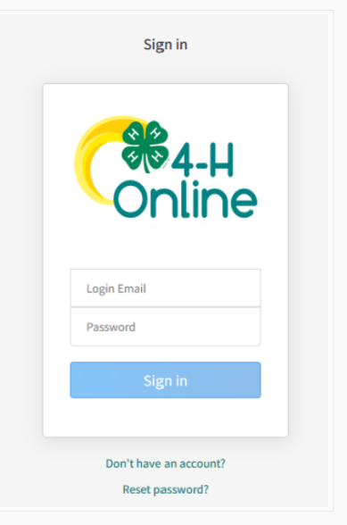
1. If the family has forgotten their 4-H Online password, they need to click “Reset Password?” on the login screen (https://v2.4honline.com)

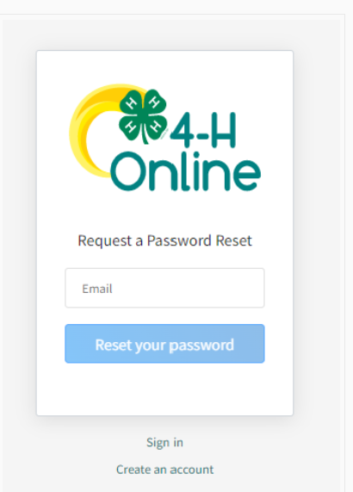
2. Enter their family email address and click the Reset your Password button.

3. Family should check their email account. Click the Reset Password button in the email they receive.

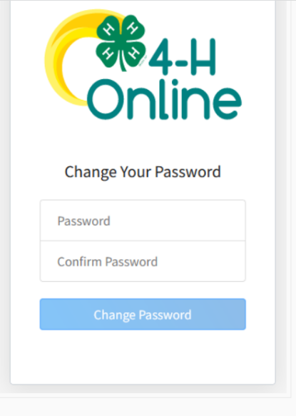
4. They will be prompted to enter and confirm a new password for their account. Then click Change Password.

5. After changing the password, they will be need to go to: https://v2.4honline.com/#/user/sign-in and sign-in with their email address and newly set password.

